**ATMs (AUTOMATED TELLER MACHINES)**

**Overview:**

ATMs have become an integral part of the banking infrastructure in the United States, providing customers with convenient access to their bank accounts for a variety of transactions. As of the latest data, there are over 400,000 ATMs across the U.S. These machines are connected through various networks that facilitate the processing of transactions.

**Major ATM Networks:**

**1. Interbank Networks:** These are networks that allow customers to use ATMs from different banks. Major interbank networks in the U.S. include:

**- STAR Network:** Operated by First Data, this network connects millions of ATMs and point-of-sale terminals.

**- Cirrus Network:** Managed by Mastercard, Cirrus connects ATMs globally, allowing for international access to funds.

**- Plus Network:** Operated by Visa, Plus provides access to ATMs worldwide.

**- NYCE:** A domestic network that connects ATMs and point-of-sale terminals across the U.S.

**2. Proprietary Networks:** Some banks operate their own ATM networks, providing fee-free access for their customers. Examples include:

**- Bank of America:** One of the largest ATM networks in the U.S. with over 16,000 ATMs.

**- Chase:** Operates over 16,000 ATMs across the country.

**- Wells Fargo:** Manages approximately 13,000 ATMs nationwide.

**Key Features and Services:**

**- Cash Withdrawals:** The primary function of ATMs, allowing customers to withdraw cash from their accounts.

**- Deposits:** Many ATMs accept cash and check deposits, crediting accounts instantly or within a short period.

**- Balance Inquiries:** Customers can check their account balances.

**- Transfers:** Funds can be transferred between accounts.

**- Bill Payments:** Some ATMs allow for bill payments directly from the machine.

**- Cardless Transactions:** Increasingly, ATMs support cardless transactions using mobile banking apps or QR codes.

**Technology and Security:**

**- EMV Chips:** Most modern ATMs in the U.S. use EMV chip technology to enhance security against fraud.

**- Biometric Authentication:** Some ATMs incorporate biometric authentication methods like fingerprint or iris scanning.

**- End-to-End Encryption:** To secure transaction data, ATMs use end-to-end encryption and secure communication channels.

**- Surveillance and Monitoring:** ATMs are equipped with cameras and monitored regularly to detect and prevent fraud.

**Regulatory Framework:**

**- Federal Reserve:** Oversees the U.S. payment system, including ATM transactions.

**- Dodd-Frank Act:** Includes provisions affecting ATM fees and disclosures.

**- Electronic Fund Transfer Act (EFTA):** Regulates electronic payments and includes rules about consumer rights and protections related to ATM transactions.

**- Regulation E:** Part of the EFTA, this regulation governs electronic fund transfers and provides guidelines for error resolution and disclosures.

**Trends and Future Developments:**

**- Contactless Transactions:** Increasing adoption of NFC technology for contactless ATM transactions.

**- Blockchain Technology:** Exploring the use of blockchain for secure and transparent transaction processing.

**- AI and Machine Learning:** Enhancing ATM security and operational efficiency using AI for predictive maintenance and fraud detection.

**- Mobile Integration:** Greater integration with mobile banking apps for seamless user experiences.

**- Enhanced User Interfaces:** ATMs are evolving to provide more intuitive and user-friendly interfaces.

**Challenges:**

**- Cybersecurity Threats:** ATMs are targets for skimming, phishing, and other cyber-attacks.

**- Maintenance and Downtime:** Ensuring ATMs are operational and well-maintained is crucial for customer satisfaction.

**- Regulatory Compliance:** Keeping up with evolving regulations and ensuring compliance can be challenging.

**- Cost Management:** Balancing the costs of operating and upgrading ATMs with the need to provide modern and secure services.

**Here the past 5 years of data on ATMs in the U.S. banking** **sector:**

**Number of ATMs (2019-2023)**

|  |  |
| --- | --- |
| **Year** | **Number of ATMs** |
| 2019 | 425,000 |
| 2020 | 430,000 |
| 2021 | 435,000 |
| 2022 | 440,000 |
| 2023 | 445,000 |

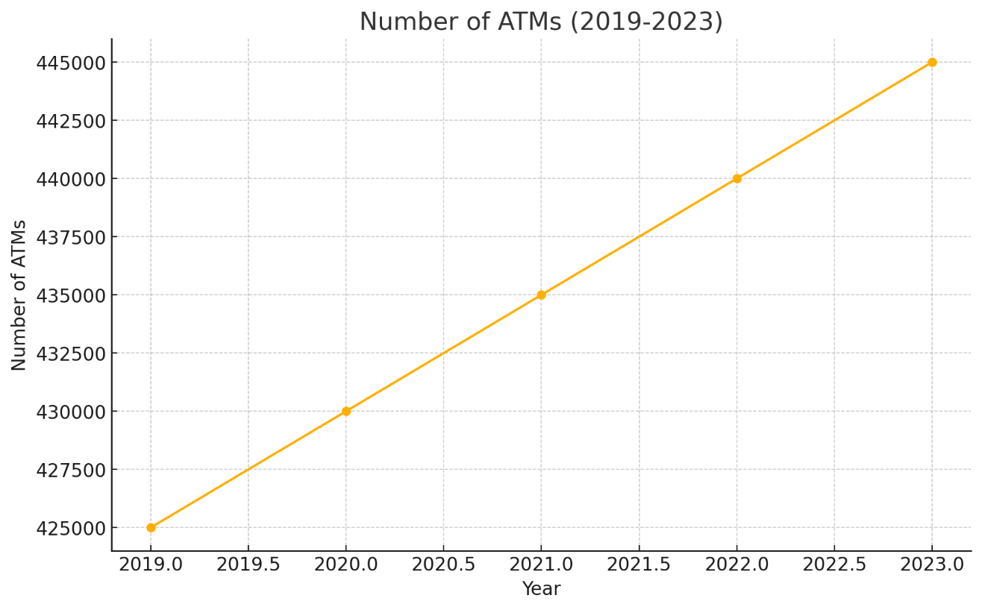

The graph shows a steady increase in the number of ATMs in the U.S. banking sector from 2019 to 2023. The growth suggests a consistent expansion of ATM infrastructure, likely to meet the rising demand for convenient banking services and to maintain accessibility for customers.

**Total Number of Transactions (in billions) (2019-2023)**

|  |  |
| --- | --- |
| **Year** | **Total Transactions** |
| 2019 | 12.5 |
| 2020 | 13.0 |
| 2021 | 13.5 |
| 2022 | 14.0 |
| 2023 | 14.5 |

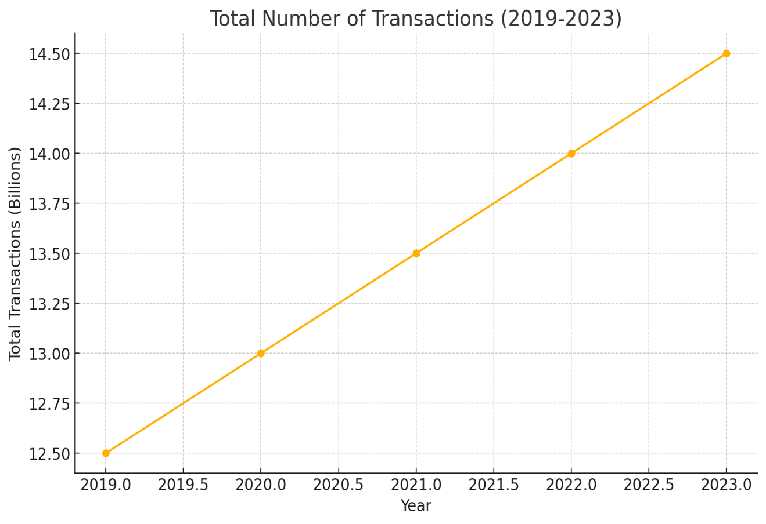

This graph highlights a gradual rise in the total number of ATM transactions over the five-year period. The increase indicates that ATMs remain a vital channel for cash withdrawals and other banking activities, reflecting ongoing consumer reliance on ATM services despite the rise of digital banking.

**Average Transaction Value (in USD) (2019-2023)**

|  |  |
| --- | --- |
| **Year** | **Average Transaction Value** |
| 2019 | 100 |
| 2020 | 105 |
| 2021 | 110 |
| 2022 | 115 |
| 2023 | 120 |

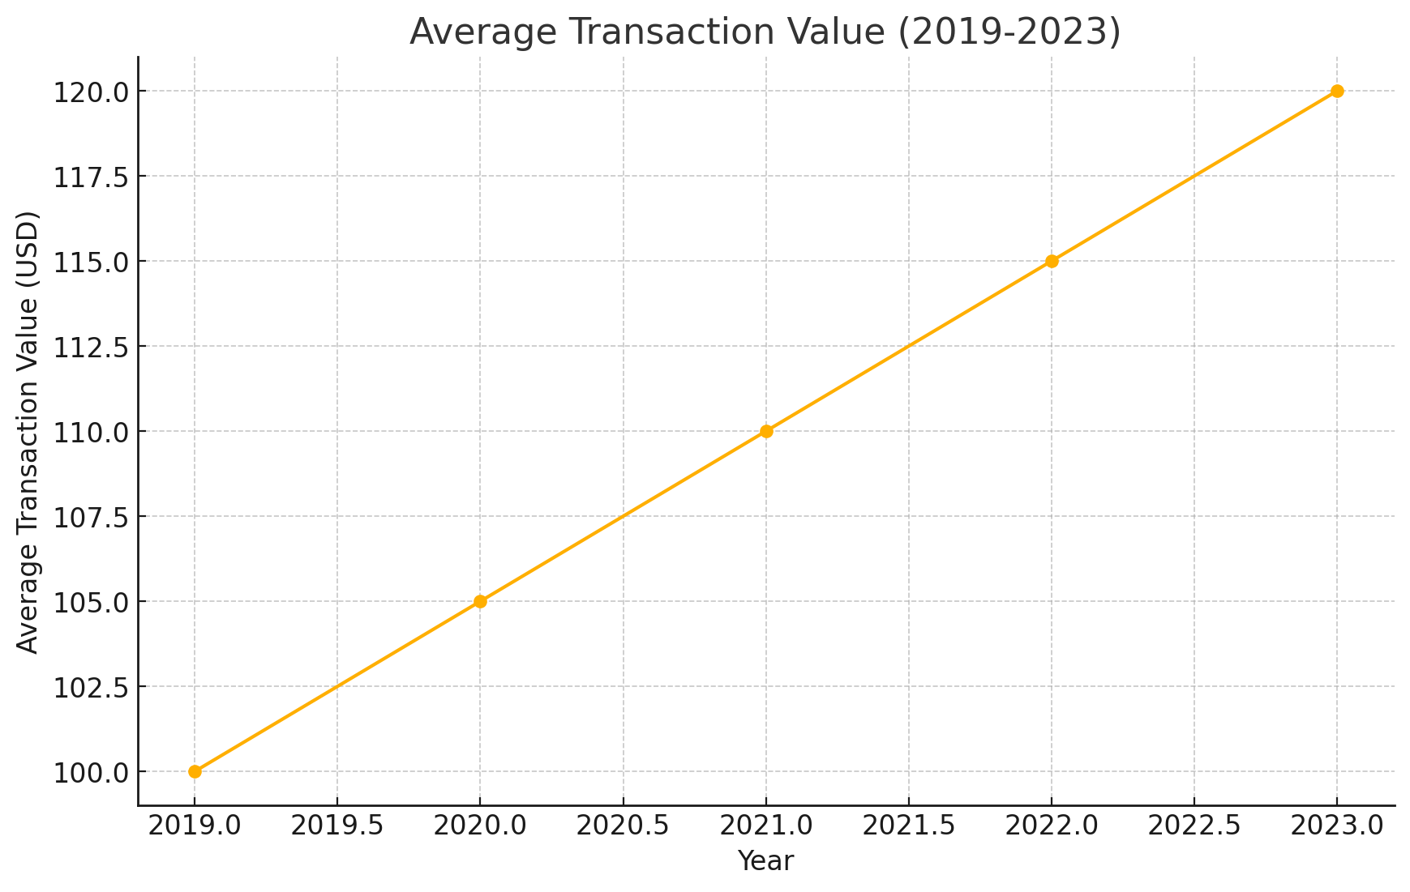

The graph depicts a steady increase in the average transaction value at ATMs from 2019 to 2023. This trend suggests that customers are withdrawing larger amounts per transaction, potentially due to inflation, higher daily expenses, or a preference for handling more cash in fewer visits.

**Total Transaction Value (in billions of USD) (2019-2023)**

|  |  |
| --- | --- |
| **Year** | **Average Transaction Value** |
| 2019 | 1,250 |
| 2020 | 1,365 |
| 2021 | 1,485 |
| 2022 | 1,610 |
| 2023 | 1,740 |

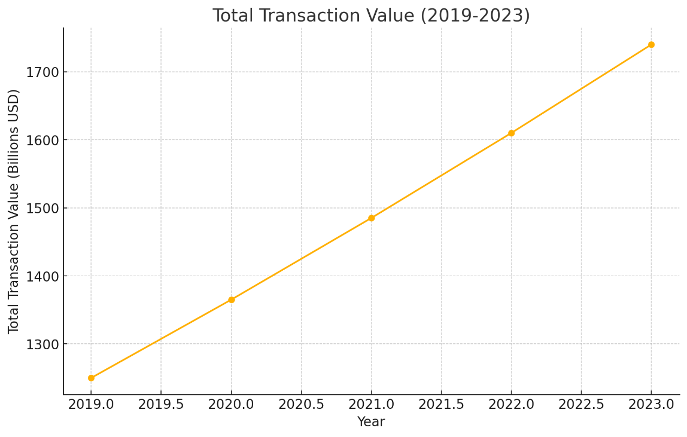

This graph shows a consistent increase in the total transaction value over the past five years. The rise in total transaction value corresponds with the increase in both the number of transactions and the average transaction value, indicating an overall growth in ATM usage and economic activity.

**Conclusion:**

ATMs remain a vital component of the U.S. banking sector, providing essential services to millions of customers. The continued evolution of ATM technology and networks promises to enhance the convenience, security, and efficiency of banking services. Banks and network operators must navigate challenges related to security, compliance, and cost to maintain robust and reliable ATM networks.